**1.Write a C program to print natural numbers from 1 to 10 using while loop**

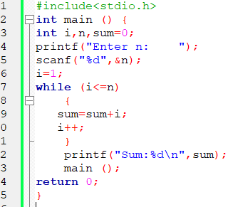

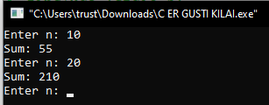

**2. C program to print natural numbers in reverse from n to 1**

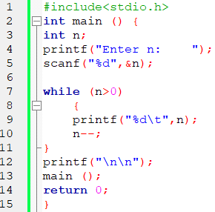

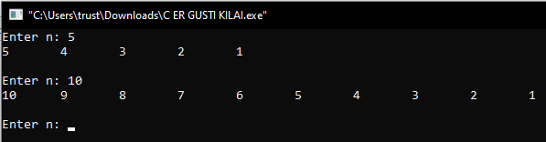

**3. Program to count total digits in a given integer using do while loop**

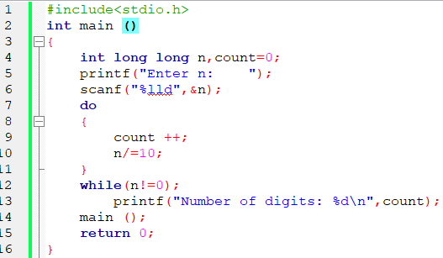

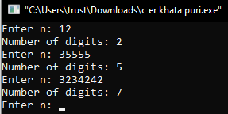

**4. C program to find sum of digits of a number**

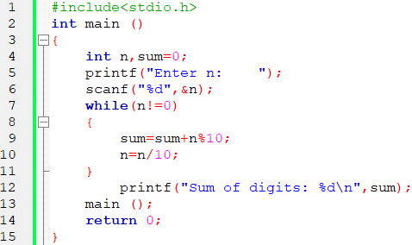

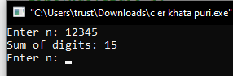

**5. C program to find reverse of a number**

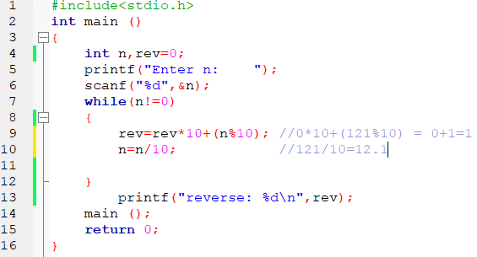

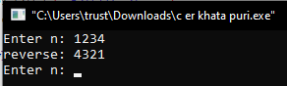

**6. C program to check whether a number is palindrome or not**

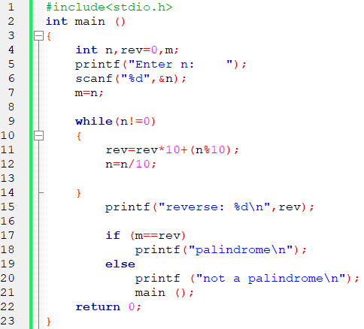

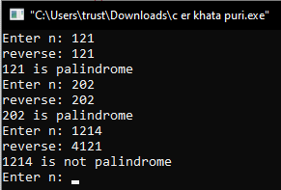

**7. C program to find HCF (GCD) of two numbers**

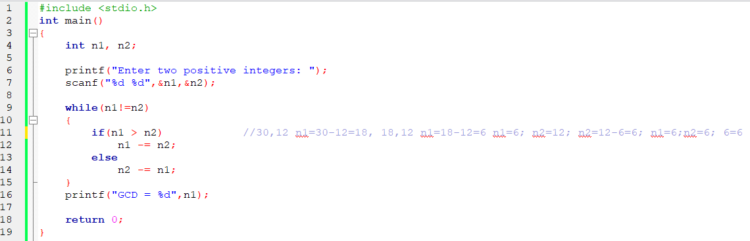

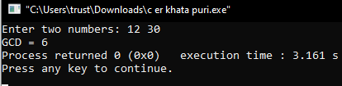

**8. C program to check whether a number is Armstrong number or not**

**